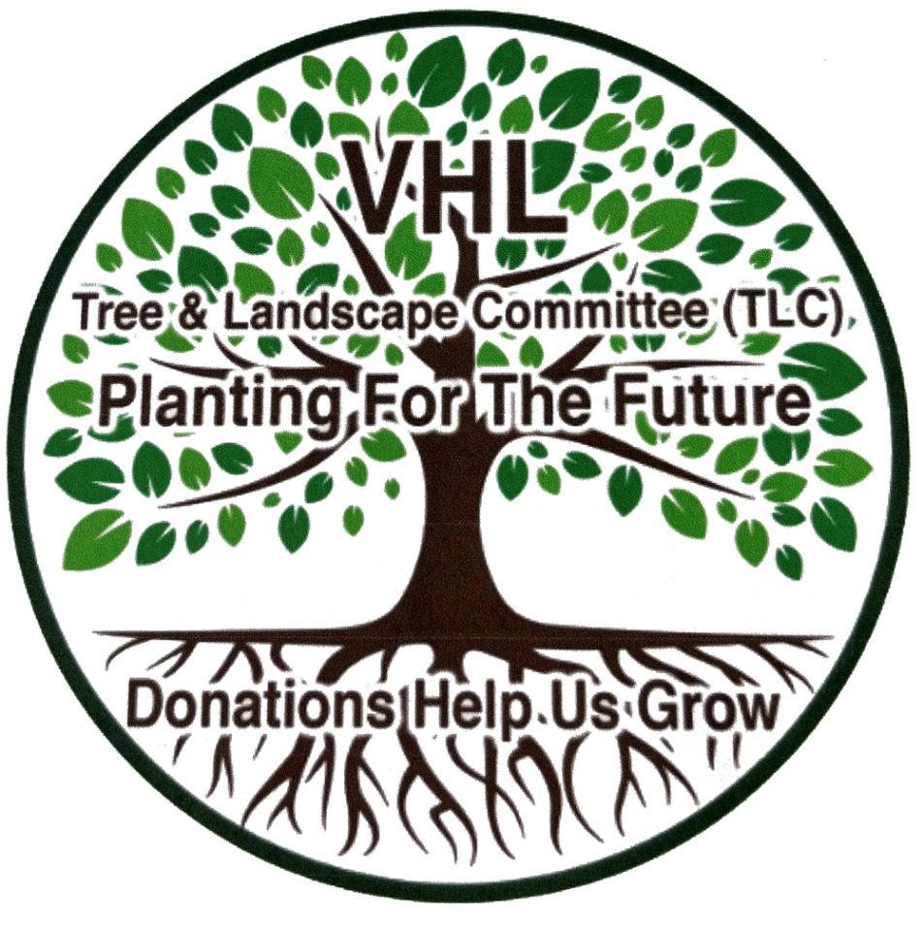
PLEASE DONATE NOW
PLEASE DONATE NOW
VHL Tree & Landscape Cttee. (TLC)
We plan and beautify VHL Park
We develop great projects every year
We have a Team with talent, experience and support
We hold/support fundraising events
Trees add value to all owner’s property
Contact: Ian 1 416-930-3173. Eric 1 630-347-6081
VHL Tree & Landscape Cttee. (TLC)
We plan and beautify VHL Park
We develop great projects every year
We have a Team with talent, experience and support
We hold/support fundraising events
Trees add value to all owner’s property
Contact: Ian 1 416-930-3173. Eric 1 630-347-6081

